Title of the proposal

Facility requested
Group leader name

methodology and ACCESS PLAN

It is expected that this document (2 pages maximum) includes a detailed description of the model set-up and additional technical details and specifications to aid the facility providers in assessing the project’s feasibility. The research facility and equipment, technical details and specifications of the planned experiments, necessary modifications or adaptations of the facility setup, the estimated number of access days, and the number, dates, and duration of visits should be included here. It is important to justify the duration of the access requested and the need for the requested research facility. Please consider the modality of access of the facility requested and the estimation included in the description of the facilities on https://co-udlabs.eu/access/research-facilities. User groups are encouraged to contact and discuss with facility providers technical and scientific issues during the first stages of the preparation of the proposal. Facility providers will give support for draft proposals through the Co-UDlabs contact form (https://co-udlabs.eu/facility-contact-form/) before 31th December 2021.

In addition, an introducing webinar and a hackathon will be organised to foster multi-institutional and multi-sectoral user groups and support the preparation of the proposals in feasibility and scientific terms between facility providers and user groups. Further information of the call and the hackathon is available on www.co-udlabs.eu. Figure 1 is an example of the style for figures if required.
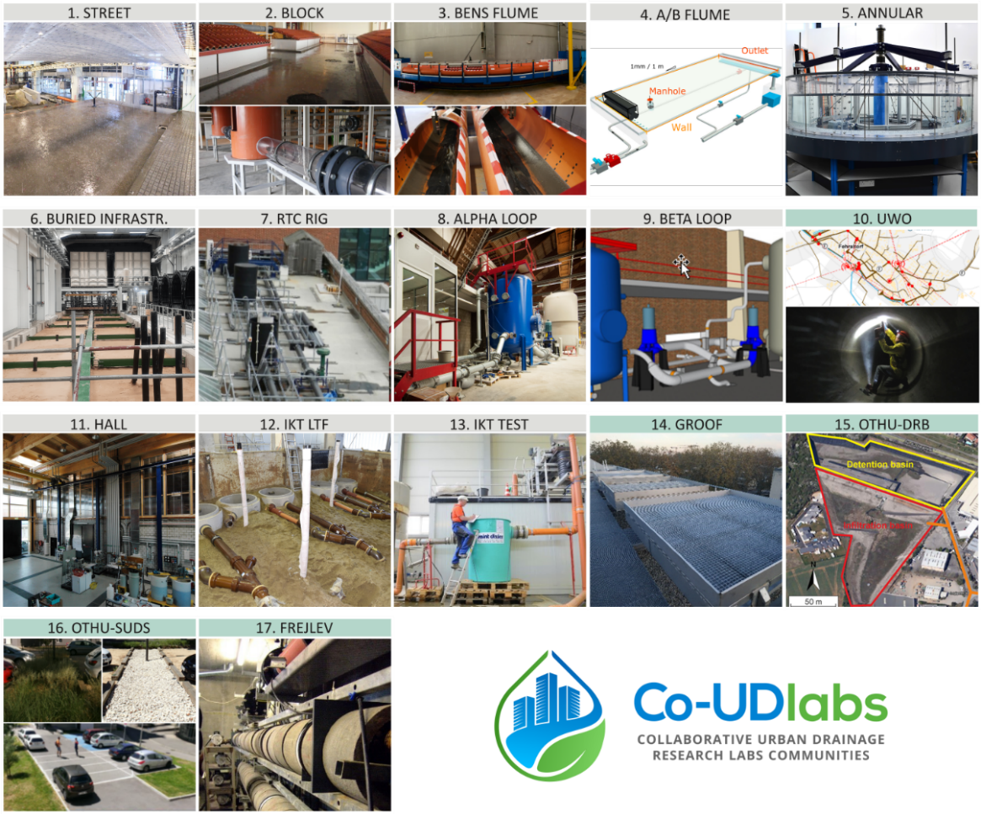
Figure 1 | Caption example.

Users shall abide by the normal working practices, working hours, and health and safety regulations of the facility provider while present at the research facility. The facility provider shall incur no liability in respect of any claim that may arise from the use of its research facility under this contract. The presence of users in the research facility occurs at their own risk. Neither the personnel of the facility provider nor the organization itself accept liability for the damage or loss of any instruments, apparatus and test equipment of the users whether or not such damage or loss was caused directly or indirectly by their negligence. Each visiting user will ensure he/she has appropriate insurance, including personal health, accident cover and personal liability. The facility provider may conclude an access contract with the user group leader.

