Title of the proposal

Facility requested
Group leader name

Abstract
This template presents the instructions needed to prepare the proposal document for the first call for transnational access of Co-UDlabs. The maximum extend of the proposal is 4 page including figures, tables and references. Please use this document as template and maintain text styles, margins and spacing. Note that proposals exceeding the size requirements or not using provided templates will not be considered for evaluation. The abstract (200 words or less in one paragraph) should briefly state the purpose and novelty of the research project, the main expected results and their impact for academic or industrial innovation. References should be avoided in abstract. Project proposals must be written in English.

Keywords | please list a maximum of 4 keywords, separated by commas and full stop at the end.

Excellence of the proposal

A brief state of the art and general description of the project is expected to be included. The aim of this section is to emphasize the effectiveness of the research approach included in the proposal and its fit with the main themes of Co-UDlabs, to highlight the quality of the proposal and its novelty in the field of urban drainage, and to demonstrate the suitability of the composition of the team to carry out the proposal. The excellence of the proposal will be evaluated by the Co-UDlabs External Evaluation Panel from 0 to 10, out of a maximum total score for the project proposal of 20 points. User group curriculum vitae will be also used in the evaluation of this criterion. User groups composed of members from a wide range of institutions, different eligible countries, and with the presence of non-academic sector will be positively considered according to the User Selection Procedure. If two proposals have the same rating, the number of first-time users and female users will be considered when making the final selection. The EEP reserves the option to reject proposals that it considers to be of insufficient scientific and/or technical quality to be considered for Transnational Access.

User groups are encouraged to contact and discuss with facility providers technical and scientific issues during the first stages of the preparation of the proposal. Facility providers will give support for draft proposals through the Co-UDlabs contact form (https://co-udlabs.eu/facility-contact-form/) before 31th December 2021. Introducing Co-UDlabs webinar and workshop, and a 2-days hackathon will be held during the call to foster multi-institutional and multi-sectoral user groups and support the preparation of the proposals in feasibility and scientific terms. Dates and procedures can be consulted on www.co-udlabs.eu/access/ta-call. TA call, Rules & Conditions and User Evaluation Procedure documents are available on the website for further information about the call.

ImPACT OF THE EXPECTED RESULTS

Outline the dissemination of the expected results with a description as to how the user group plans to disseminate the results, for example through publications, meetings and workshops and also explain how the results and data can be made open available to the wider research and innovation community. It would also be helpful if the user group could estimate the potential long term impact of the dissemination of their proposed work on the European Urban Drainage community. The relevance of the expected datasets, publications and other communications will be evaluated by the Co-UDlabs External Evaluation Panel from 0 to 5, out of a maximum total score for the project proposal of 20 points.

If the project is granted, users should draft a data management plan prior to the experiments. This plan will explain in detail how the data will be stored in such a way that researchers outside the Project can make use of it. The experiments can only start after the written approval of the Data Management Plan by the facility provider, once the proposal is selected. The publication of data papers, describing the data sets generated under the Project and that will be available at the open repository Zenodo, will be positively evaluated. These data papers will be cited as many times as required in subsequent publications. Manuscripts must be submitted to the facility provider for approval not later than 1 month before submission so that changes can be made prior to publication. Such changes will normally only be to the form of accuracy, acknowledgements, etc. Users must acknowledge in their publications that their work was financially supported by the European Union’s Horizon 2020 Research and Innovation Programme as follows: “The authors acknowledge financial support from the European Union under the Horizon 2020 program within a contract for Integrating Activities for Starting Communities (Ref. 101008626)”.

POTENTIAL FOR ACADEMIC OR INDUSTRIAL INNOVATION

The External Evaluation Panel will assess the relevance of the potential end-user applications of the project results and the possible further academic development of the research line outside the facility once the transnational access is completed. The maximum score assigned to this criterion is 5 points, out of a maximum total score for the project proposal of 20.

Subsection

Second level titles can be created within the text if required. Figures and tables can be included within the proposal and should be numbered consecutively. Tables should be designed to have a uniform style throughout the extended abstract, following the style shown in Table 1. Figure 1 is an example of figure. All references included should be listed at the end of the document within the limit of 4 pages. Please follow APA format for in-text citations and reference list.
Table 1 | Caption example.
 | Flow discharge (L/s) |  |  | TSS (mg/L)
 | T1 | T2 |  | T1 | T2
Test 1 | 0.75 | 2.7 |  | 60 | 80
Test 2 | 1.21 | 4.4 |  | 65 | 105

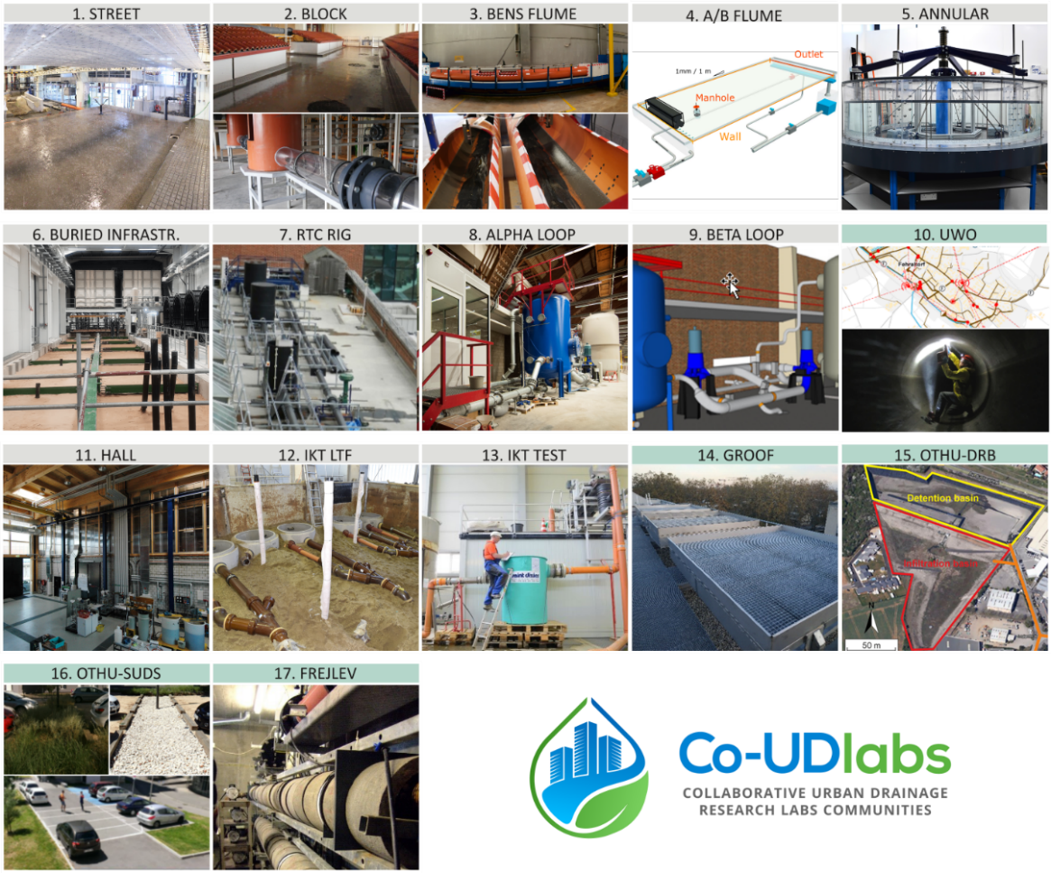
Figure 1 | Caption example.

REFERENCES

Author1, X., Author2, X.X., …, AuthorN, X. (2022). Title. Journal. 19(2), 6-10. https://doi.org/0

Author1, X., Author2, X.X., …, AuthorN, X. (2022). Title. Journal. 19(2), 6-10. https://doi.org/00

